WHAT IS LOREM IPSUM?

Phill Smith¹ and Carol Gardner^{2*}
¹Prof. Dr., Illinois University, The United States, phillsmith41@gmail.com
²Assist. Prof. Dr., University of Liverpool, The United Kingdom, gardner_carol12@yahoo.com
*Corresponding author

Abstract
Lorem ipsum A common form of lorem ipsum reads: Lorem ipsum dolor sit amet, consectetur adipisicing elit, sed do eiusmod tempor incididunt ut labore et dolore magna aliqua. Ut enim ad minim veniam, quis nostrud exercitation ullamco laboris nisi ut aliquip ex ea commodo consequat. Duis aute irure dolor in reprehenderit in voluptate velit esse cillum dolore eu fugiat nulla pariatur. Excepteur sint occaecat cupidatat non proident, sunt in culpa qui officia deserunt mollit anim id est laborum.
Keywords: Publisher, Designing, Lowercase letters.

INTRODUCTION
Lorem ipsum A common form of lorem ipsum reads: Lorem ipsum dolor sit amet, consectetur adipisicing elit, sed do eiusmod tempor incididunt ut labore et dolore magna aliqua. Ut enim ad minim veniam, quis nostrud exercitation ullamco laboris nisi ut aliquip ex ea commodo consequat. Duis aute irure dolor in reprehenderit in voluptate velit esse cillum dolore eu fugiat nulla pariatur. Excepteur sint occaecat cupidatat non proident, sunt in culpa qui officia deserunt mollit anim id est laborum.
Lorem ipsum A common form of lorem ipsum reads:Lorem ipsum dolor sit amet, consectetur adipisicing elit, sed do eiusmod tempor incididunt ut labore et dolore magna aliqua. Ut enim ad minim veniam, quis nostrud exercitation ullamco laboris nisi ut aliquip ex ea commodo consequat. Duis aute irure dolor in reprehenderit in voluptate velit esse cillum dolore eu fugiat nulla pariatur. Excepteur sint occaecat cupidatat non proident, sunt in culpa qui officia deserunt mollit anim id est laborum.

LOREM IPSUM

2.1. Lorem Ipsum
Lorem ipsum A common form of lorem ipsum reads: Lorem ipsum dolor sit amet, consectetur adipisicing elit, sed do eiusmod tempor incididunt ut labore et dolore magna aliqua. Ut enim ad minim veniam, quis nostrud exercitation ullamco laboris nisi ut aliquip ex ea commodo consequat. Duis aute irure dolor in reprehenderit in voluptate velit esse cillum dolore eu fugiat nulla pariatur. Excepteur sint occaecat cupidatat non proident, sunt in culpa qui officia deserunt mollit anim id est laborum (Ben-Daya, Darwis and Ertogral, 2008, pp. 726-742)
Lorem ipsum A common form of lorem ipsum reads:Lorem ipsum dolor sit amet, consectetur adipisicing elit, sed do eiusmod tempor incididunt ut labore et dolore magna aliqua. Ut enim ad minim veniam, quis nostrud exercitation ullamco laboris nisi ut aliquip ex ea commodo consequat. Duis aute irure dolor in reprehenderit in voluptate velit esse cillum dolore eu fugiat nulla pariatur. Excepteur sint occaecat cupidatat non proident, sunt in culpa qui officia deserunt mollit anim id est laborum (Goyal, 1977, p.108).

Lorem Ipsum
Lorem ipsum A common form of lorem ipsum reads: Lorem ipsum dolor sit amet, consectetur adipisicing elit, sed do eiusmod tempor incididunt ut labore et dolore magna aliqua. Ut enim ad minim veniam, quis nostrud exercitation ullamco laboris nisi ut aliquip ex ea commodo consequat. Duis aute irure dolor in reprehenderit in voluptate velit esse cillum dolore eu fugiat nulla pariatur. Excepteur sint occaecat cupidatat non proident, sunt in culpa qui officia deserunt mollit anim id est laborum.
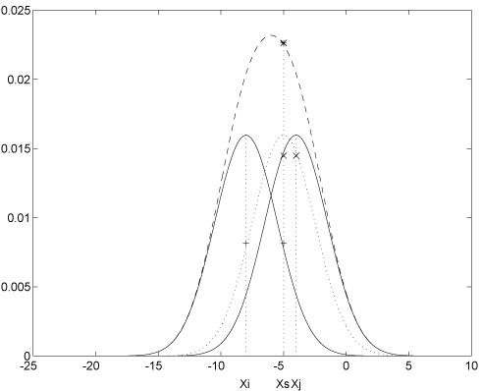
Fig. 1. One kernel at xs (dotted kernel) or two kernels at xi and xj (left and right) lead to the same summed estimate at xs. This shows a figure consisting of different types of lines. Elements of the figure described in the caption should be set in italics, in parentheses, as shown in this sample caption.
Table 1. Font sizes of headings: Table captions should always be positioned above the tables
Heading level | Example | Font size and style
Title (centered) | Lecture Notes … | 12 point, bold
1st-level heading | 1 Introduction | 12 point, bold
2nd-level heading | 2.1 Printing Area | 10 point, bold
3rd-level heading | Headings. Text follows | 10 point, bold
4th-level heading | Remark. Text follows … | 10 point, italic
Note: font size is 10 point.

ACKNOWLEDGEMENT
This research was financially supported by the National Natural Science Foundation of China (Grant NO. 00000000) and the Fundamental Research Funds for Central University (Grant NO.TD2010-2).

REFERENCE LIST
Ben-Daya, M., Darwis, M. and Ertogral, K. (2008). The joint economic lot sizing problem: Review and extensions. European Journal of Operational Research, vol. 185.
Goyal, S. K. (1977). An integrated inventory model for a single supplier-single customer problem. International Journal of Production Research, vol.15.

